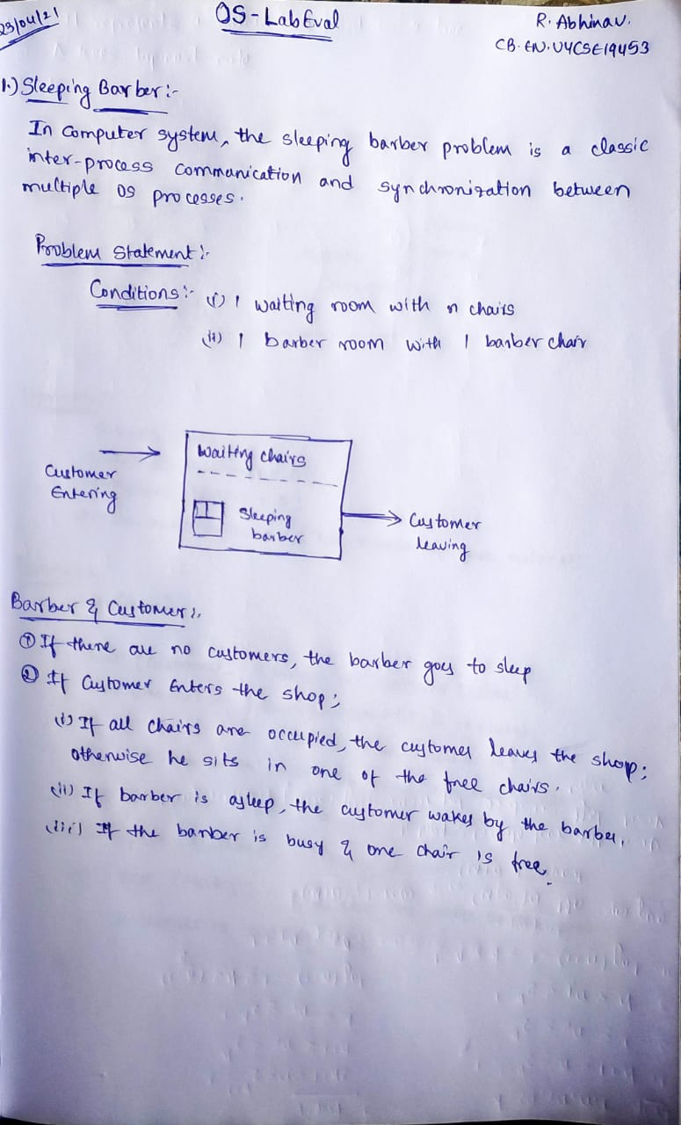

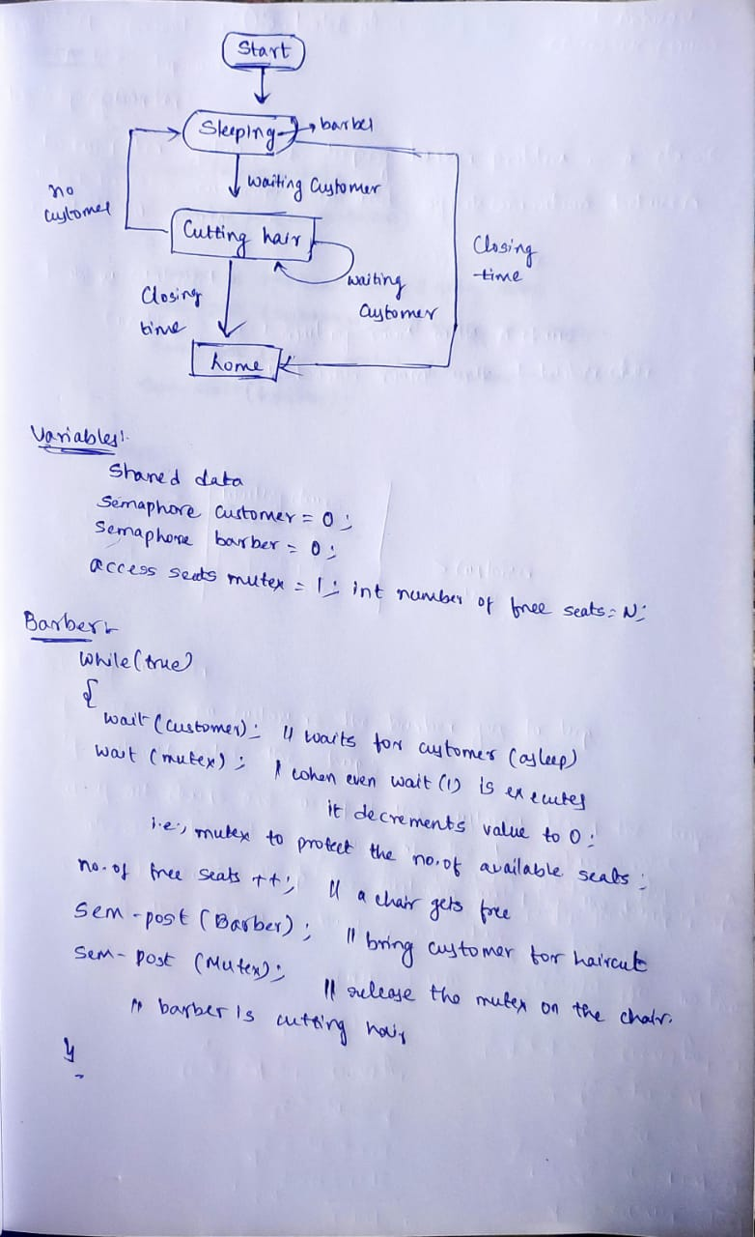

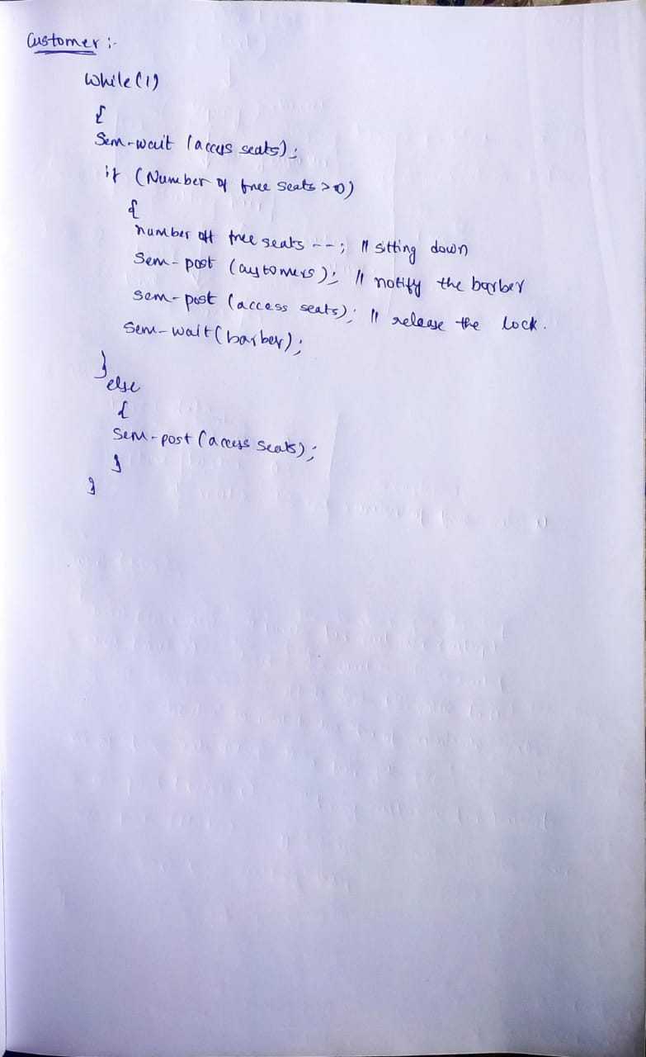

**Code :**

#include <unistd.h>

#include <stdio.h>

#include <stdlib.h>

#include <pthread.h>

#include <semaphore.h>

#define MAX_CHAIRS 10

#define CUT_TIME 1

#define NUM_BARB 2

#define MAX_CUST 30

sem_t customers;

sem_t barbers;

sem_t mutex;

int numberOfFreeSeats = MAX_CHAIRS;

int seatPocket[MAX_CHAIRS];

int sitHereNext = 0;

int serveMeNext = 0;

static int count = 0;

void barberThread(void *tmp);

void customerThread(void *tmp);

void wait();

int main()

{

pthread_t barber[NUM_BARB],customer[MAX_CUST];

int i,status=0;

sem_init(&customers,0,0);

sem_init(&barbers,0,0);

sem_init(&mutex,0,1);

printf("Good Morning!!\n");

for(i=0;i<NUM_BARB;i++)

{

status=pthread_create(&barber[i],NULL,(void )barberThread,(void)&i);

sleep(1);

if(status!=0)

perror("No Barber Present... Sorry!!\n");

}

for(i=0;i<MAX_CUST;i++)

{

status=pthread_create(&customer[i],NULL,(void )customerThread,(void)&i);

wait();

if(status!=0)

perror("No Customers Yet!!!\n");

}

for(i=0;i<MAX_CUST;i++)

pthread_join(customer[i],NULL);

printf("!!Barber Shop Closes!!\n");

exit(EXIT_SUCCESS);

}

void customerThread(void *tmp)

{

int mySeat, B;

sem_wait(&mutex);

count++;

printf("Customer-%d[Id:%d] Entered Shop. ",count,pthread_self());

if(numberOfFreeSeats > 0)

{

--numberOfFreeSeats;

printf("Customer-%d Sits In Waiting Room.\n",count);

sitHereNext = (++sitHereNext) % MAX_CHAIRS;

mySeat = sitHereNext;

seatPocket[mySeat] = count;

sem_post(&mutex);

sem_post(&barbers);

sem_wait(&customers);

sem_wait(&mutex);

B = seatPocket[mySeat];

numberOfFreeSeats++;

sem_post(&mutex);

}

else

{

sem_post(&mutex);

printf("Customer-%d Finds No Seat & Leaves.\n",count);

}

pthread_exit(0);

}

void barberThread(void *tmp)

{

int index = *(int *)(tmp);

int myNext, C;

printf("Barber-%d[Id:%d] Joins Shop. ",index,pthread_self());

while(1)

{

printf("Barber-%d Gone To Sleep.\n",index);

sem_wait(&barbers);

sem_wait(&mutex);

serveMeNext = (++serveMeNext) % MAX_CHAIRS;

myNext = serveMeNext;

C = seatPocket[myNext];

seatPocket[myNext] = pthread_self();

sem_post(&mutex);

sem_post(&customers);

printf("Barber-%d Wakes Up & Is Cutting Hair Of Customer-%d.\n",index,C);

sleep(CUT_TIME);

printf("Barber-%d Finishes. ",index);

}

}

void wait()

{

int x = rand() % (250000 - 50000 + 1) + 50000;

srand(time(NULL));

usleep(x);

}

**Output :**

